- What is Databricks Delta Lake?
Delta Lake is an open-source storage layer created by Databricks that sits on top of a Data Lake and adds database-like reliability.

Data Lake + ACID Transactions + Data Versioning + Better Performance = Delta Lake

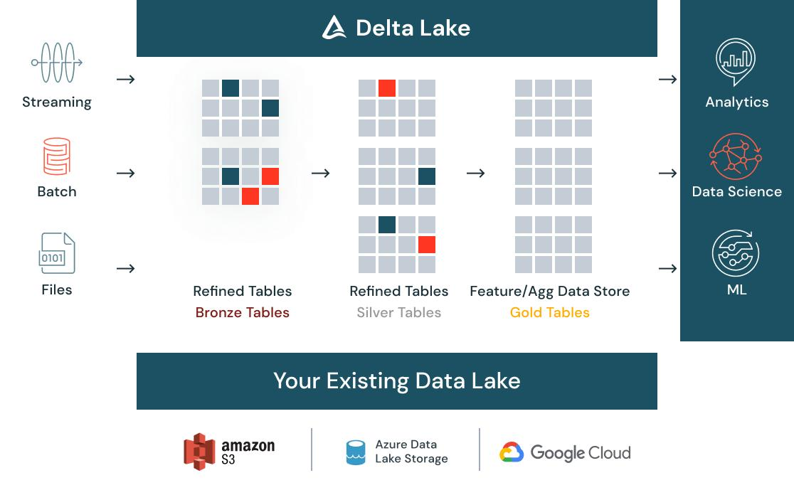
Real-Life Example
Netflix.
Database
Stores current user information:
User ID | Name | Subscription
101 | John | Premium
Data Warehouse
Stores summarized business reports:
Month | Revenue
Jan | $10M
Feb | $12M
Data Lake
Stores EVERYTHING:
- Movies metadata
- Watch history
- Clickstream logs
- Images
- Videos
- Customer reviews
Raw data is dumped here.
Delta Lake
Same Data Lake but smarter:
- Prevents corrupted writes
- Tracks changes
- Allows rollback
- Faster analytics
- Supports streaming

Database: Stores structured operational data for day-to-day transactions.
Data Warehouse: Stores cleaned and transformed data optimized for reporting and analytics.
Data Lake: Stores raw structured, semi-structured, and unstructured data at large scale.
Delta Lake: A Data Lake enhanced with ACID transactions, schema enforcement, versioning, and high-performance analytics.
